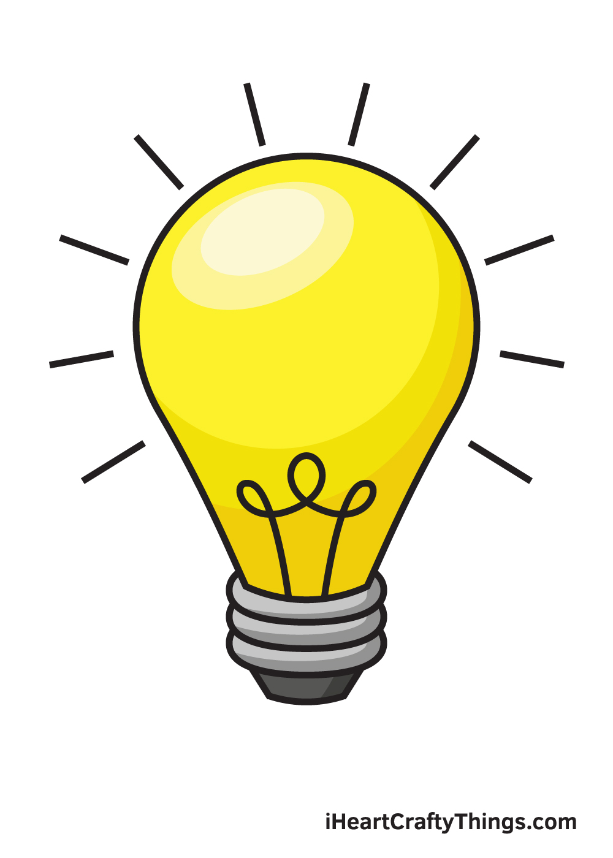
PSHE

- Relationships
- Changing me
Science
- Plants
- Animals including humans

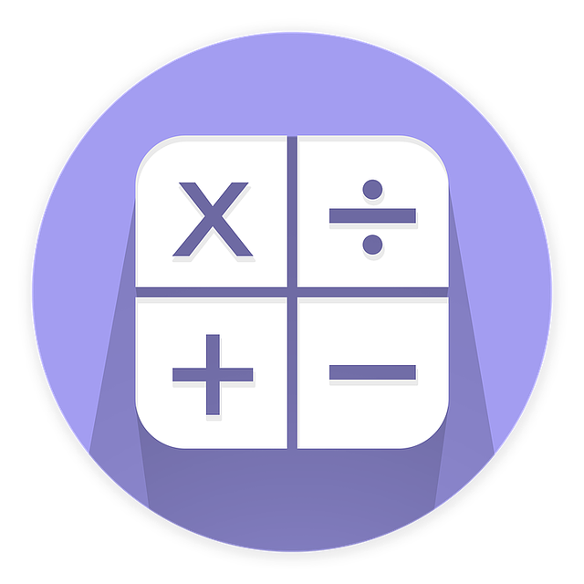Maths
- Fractions
- Money
- Time
- Shape
- Statistics
Music
- ‘Bring Us Together’ and ‘Reflect, Rewind and Replay’
- Listening and appraising, singing and improvising
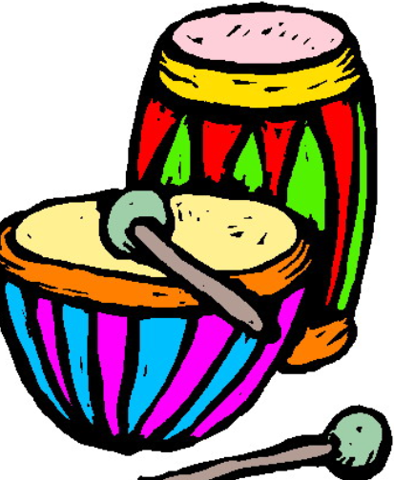
Summer Term
in Lapwings
French 
- Our school
- Time
PE
- Athletics
- Boccia
- Tennis
- Cricket


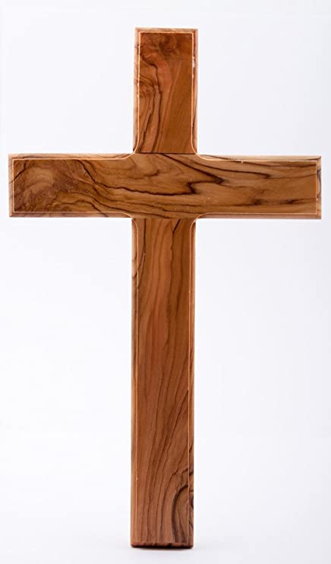
RE
- Hindu beliefs and Brahman
- Pilgrimage to the River Ganges
History
- Cornish Mining

Geography

- The United Kingdom

Computing
- Branching databases
- Events and actions (Scratch)

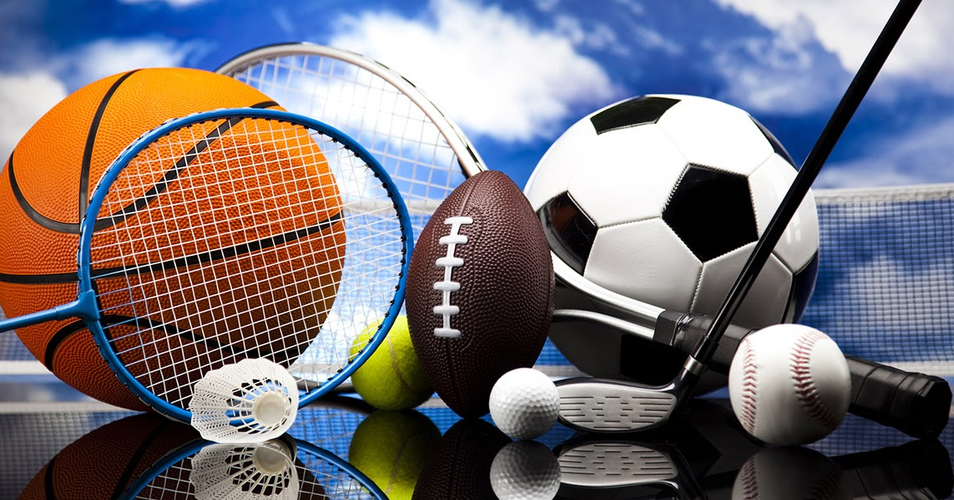


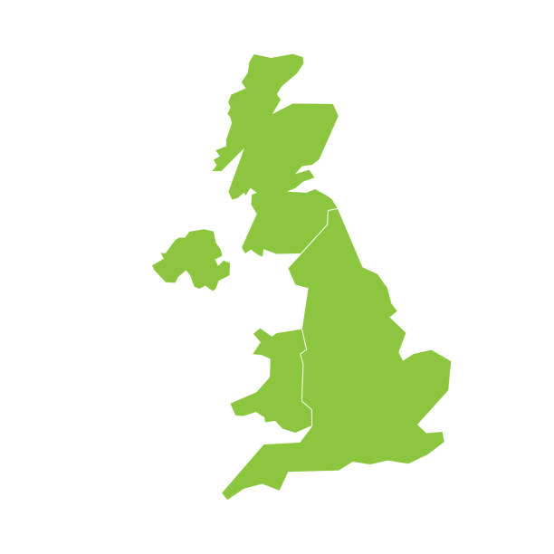
Literacy
- Reading:
The Wild Robot and The Iron Man

- Writing:
Setting descriptions
Poetry
Persuasive writing

Art
- Making animated drawings
- Using natural materials to make images
DT
- What display will your class share?

